Data Flow Diagrams:

Project Design Phase-II

Data Flow Diagram & User Stories

Date | 08-12-2025
Team ID | SWUID202560312
Project Name | Freelance Finder
Maximum Marks | 4 Marks

A Data Flow Diagram (DFD) shows how information moves through the Freelance Finder platform. It explains how freelancers and clients use the system, how data passes between different parts, and where it is stored.

Example: DFD Level 0 (Industry Standard)

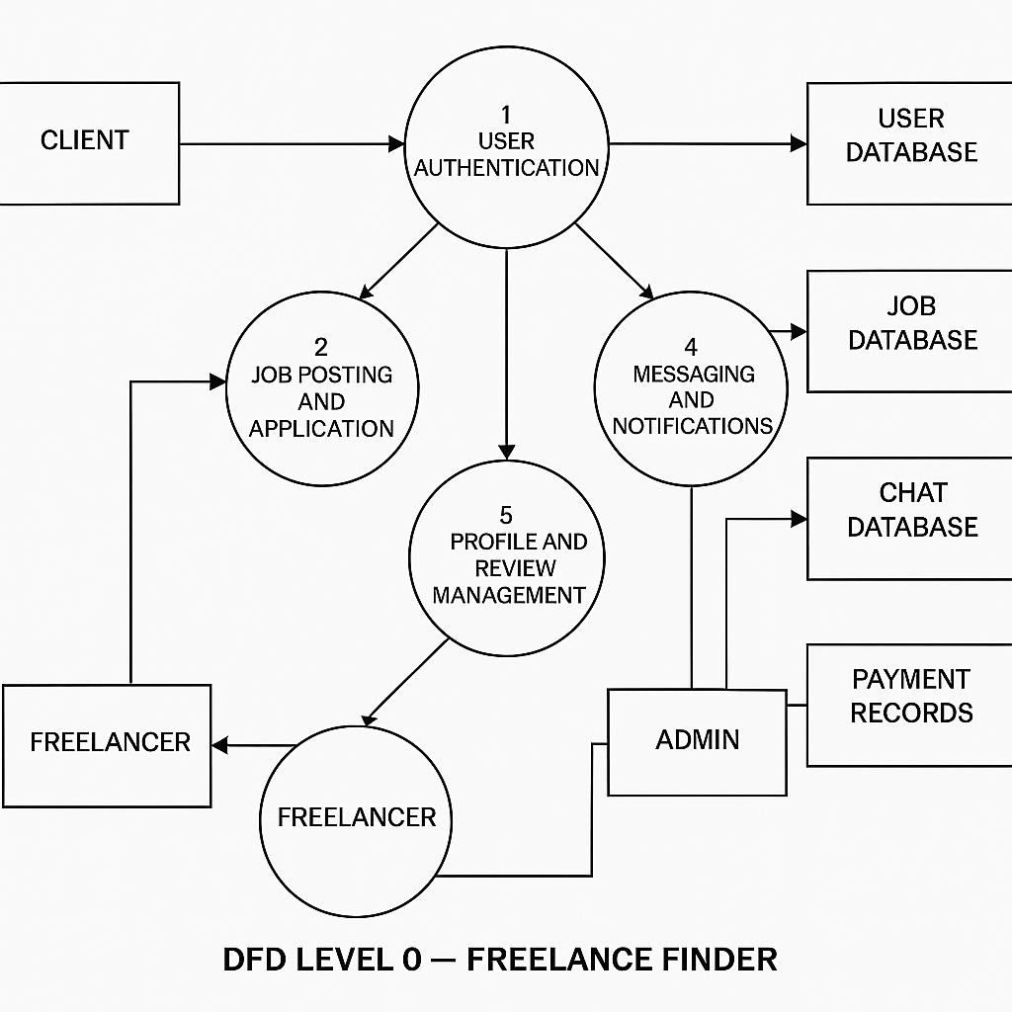

User Stories

User Story Table – Freelance Finder

User Type | Functional Requirement (Epic) | User Story / Task | Acceptance Criteria | Priority | Release
Client | Job Posting | As a client, I can post a new freelance job. | Job appears on homepage and my dashboard. | High | Sprint-1
 | Job Browsing | As a freelancer, I can browse and filter available job | Filter returns relevant results. | Medium | Sprint-2

Freelancer | Job Application | As a freelancer, I can apply to a job with a proposal. | Application visible to client. | High | Sprint-1
User | Messaging | As a user, I can chat with the other party in real-time. | Messages appear instantly. | Medium | Sprint-2
Freelancer | Profile Management | As a freelancer, I can update my profile and portfolio. | Changes are saved successfully. | High | Sprint-2
Client | Payment Processing | As a client, I can make secure payments after job completion. | Payment recorded and shown in transaction history. | High | Sprint-2
user | Review System | As a user, I can leave a review after project closure. | Review appears on profile. | Medium | Sprint-2
Admin | User Moderation | As an admin, I can review reported users and take action. | Reports and actions logged. | High | Sprint-1

